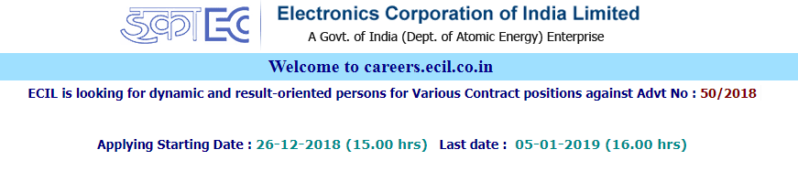
- Jr. Technical Officer on contract :
http://careers.ecil.co.in/app/Jr_TO-C_50_2018.pdf
Engineering Degree in Electronics & Communication Engineering / Electrical Electronics Engineering / Electronics & Instrumentation Engineering / Mechanical Engineering / Computer Science Engineering/ Information Technology with minimum 60% marks in aggregate from any recognized Institution / University.
- Jr. Consultant Filed Operation [Gr-1] on Contract :
http://careers.ecil.co.in/app/Jr_consult_1_50_2018.pdf
Full time Diploma Diploma in Engineering in the disciplines of Electronics& Communication Engineering / Electrical / Electronics & Instrumentation Engineering / Mechanical Engineering / Computer Science with at least 60% aggregate marks from any institution recognized by the State Board of Technical Education.
- Jr. Consultant Filed Operation [Gr-2] on Contract:
http://careers.ecil.co.in/app/Jr_consult_2_50_2018.pdf
Should have passed ITI (2 years duration) in the trades of Electronic Mechanic/R & TV/ Electrical and Fitter from the duly recognized Institute
Link & Apply: https://ecerp01.ecil.gov.in/ecilerec#
*The Nos. of posts notified for post no. 2 and 3 will be interchangeable in case of non-availability of the candidates in respective categories

